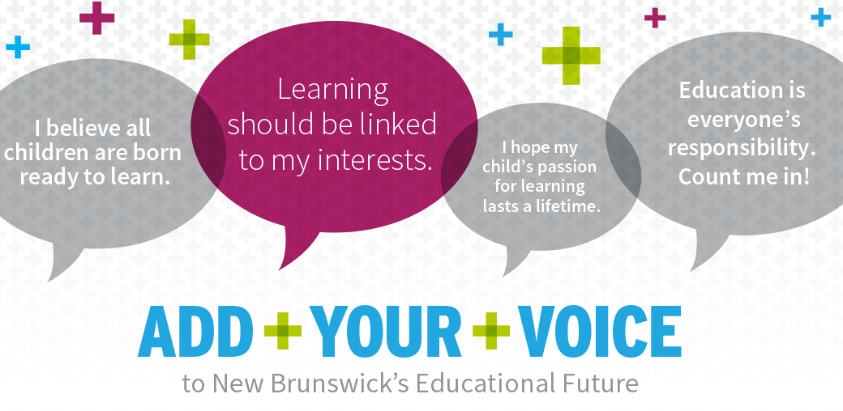
Help Build Our 10-Year Education Plan
We need New Brunswickers like you to share their ideas and insights as the Government of New Brunswick gets ready to develop its 10-Year Education Plan.
Check out the information on this site, fill out the online survey and see when there’s an Open House happening near you. Add your voice today!
www.EducationPlanNB.ca
October 22 – Florenceville-Bristol
5 p.m. – 8 p.m.
Florenceville Middle School
8470 Main St.

